OUM
EA.075 SOA Reference Architecture
<Company Long Name>
<Subject>

When this template is completed, delete all the yellow notes as follows:
1. With your document open, open the Find and Replace window.
2. Expand the Find and Replace window using the More>> button.
3. Place the cursor in the Find what: field.
4. Choose Format > Style.
5. When the Find Style box opens, scroll through the list and select Note and click OK.
6. Leave the Replace with: field blank.
7. Select Replace, Replace All or Find Next to remove the yellow notes.
8. Repeat using the Note Wide style if there are any landscape sections that contain wide yellow notes.
Please refer to the OUM Template User’s Guide for detailed instructions for working with OUM templates.

Author: <Author>
Creation Date: May 11, 2014
Last Updated: January 12, 2016
Document Ref: <Document Reference Number>
Version: DRAFT 1A

Title, Subject, Last Updated Date, Reference Number, and Version are marked by a Word Bookmark so that they can be easily reproduced in the header and footer of documents. When you change any of these values, be careful not to accidentally delete the bookmark. You can make bookmarks visible by selecting the Office Button>Word Options>Advanced> and checking the Show bookmarks option in the Show document content region.

Approvals:
<Approver 1>
<Approver 2>
To add additional approval lines, press Tab from the last cell in the table above.
You can delete any elements of this cover page that you do not need for your document.

Document Control

Change Record
5
Date | Author | Version | Change Reference
5-Oct-09 | <Author> | Draft 1a | No Previous Document

Reviewers

Name | Position

Contents
1 Document Control iii
1.1 Change Record iii
1.2 Reviewers iii
2 Introduction 1
2.1 Purpose 1
2.2 Audience 1
2.3 Related Documents 1
3 Context for SOA 2
3.1 Business Drivers 2
3.2 IT Drivers 2
3.3 SOA Objectives 2
3.4 SOA Challenges 2
3.5 SOA Architecture Principles 3
4 <Company Long Name> Service-Oriented Architecture 4
4.1 Shared Services 4
5 SOA Infrastructure 10
6 Service Providers 12
7 Service Consumers 13
8 Conceptual View 14
8.1 Connectivity Services 14
8.2 Data Services 15
8.3 Business Services 16
8.4 Business Process Services 16
8.5 Presentation Services 17
8.6 Composite Applications 17
8.7 Service Mediation 18
8.8 Service Discovery: 19
8.9 Service Governance 19
8.10 Service Management and Monitoring 20
8.11 SOA Security 20
8.12 Infrastructure Services 21
9 Implementation View 22
9.1 Technology and Product Mapping 22
10 Deployment View 24
10.1 Service Packaging 24
10.2 Service Deployment Strategy 24
10.3 Infrastructure Deployment Strategy 24
11 SOA and Enterprise Architecture 26
11.1 Application Architecture 26
11.2 Data Architecture 26
11.3 Integration Architecture 26
11.4 Security Architecture 27
11.5 OA&M 27
11.6 SOA and Business Process Management 27
11.7 SOA and Event-Driven Architecture 27
11.8 SOA and Enterprise Social Computing 28
12 Appendix A - Glossary 29
13 Appendix B – Referenced Documents 30
14 Open and Closed Issues 31
14.1 Open Issues 31
14.2 Closed Issues 31

To update the table of contents, put the cursor anywhere in the table and press F9. To change the number of levels displayed, select the menu option Insert->Index and Tables, make sure the Table of Contents tab is active, and change the Number of Levels to a new value.

Introduction
This document defines the <Company Long Name> SOA Reference Architecture.
This document contains the information needed by Portfolio Architects and Shared Services Architects to assist them in making architecture and design decisions on the projects under their purview that will enable convergence on the SOA reference architecture. The enrichment of the content in this document will be a direct result of the decisions made by the architects and designers on these projects

Purpose
The objectives of the <Company Long Name> SOA Reference Architecture document are:
- To define the framework for the architecture and design efforts of all projects on the SOA roadmap
- Provide traceability from business and IT objectives through architecture to implementation
- Provide a common vocabulary to communicate overarching SOA architecture principles and direction across multiple communities with <Company Long Name> including IT and business groups
- Provide the means against which to measure architectural compliance of the work product from the various <Company Long Name> IT teams chartered to produce SOA solutions
This document is the <Company Long Name> SOA Reference Architecture document. While it does define a subset, it does not define the <Company Long Name> Enterprise Architecture.

Audience
This document is intended for portfolio architects and technical and shared business service architects. These architects must understand the relationship among the major components of the <Company Long Name> SOA Reference Architecture and will use this to guide the architecture and design decisions on the projects under their purview. This document would also benefit other technical audiences and it is recommended that it be required reading for all SOA project designers and development leads to give them an appreciation of the same.

Related Documents

Context for SOA
This section provides the business and IT management input on the drivers for the SOA initiative, the objectives for SOA, and recognition of the challenges being faced.
Explain how information for these sections was captured. (Usually done in the preceding Reference Architecture Planning stages)

Business Drivers
The stated <Company Long Name> business drivers are:
List drivers

IT Drivers
The stated <Company Long Name> IT drivers are:
List drivers
These IT drivers have broader application than the SOA initiative, however they directly relate to the decision to pursue an SOA initiative at <Company Long Name> as the way to address them.

SOA Objectives
Describe what the customer is trying to achieve through the adoption of SOA. What benefits are they looking for. This should relate to business and IT drivers.

SOA Challenges
What known challenges exist with the adoption of SOA for this customer? Examples could be:
Organizational: Siloed development groups don’t share assets or infrastructure, or, most work is outsourced
Governance: No leadership team in place to enforce compliance
Financial: Current funding does not account for resource sharing
Technical: Current approved technology stack is not compatible with SOA technologies
Educational: Lack of SOA skills
For each challenge, provide some form of mitigation (if possible). Also make note of reference architecture decisions influenced by SOA objectives and risk mitigation.

SOA Architecture Principles
The <Company Long Name> SOA Reference Architecture defines the target architecture and the principles to be used by <Company Long Name> architects to make architecture and design decisions on their projects. The reference architecture provides a conceptual view to a desired outcome on a three-year planning window. This is a “living” document and incremental releases of the reference architecture will be produced at regular intervals during the execution of the SOA Roadmap.
The terminology used in this document is as follows:
- Principle
  - An unequivocal statement defining the future vision reference architecture.
- Guideline
  - Guidance to architects and designers on how to implement the architecture principles in given scenarios. These should drive convergence to the reference architecture over time.
<Company Long Name> has determined that the SOA reference architecture will be based on the following principles. All architectural decisions should be traceable back to some of these principles.
list principles

<Company Long Name> Service-Oriented Architecture
The intent of SOA is to provide common reusable services that can be leveraged by a variety of consumers. These services will typically originate from functionality and data that already exist in the enterprise. Services are created by “service-enabling” legacy assets. As new projects are implemented, standalone services may also emerge as autonomous entities that do not have dependencies on legacy systems.
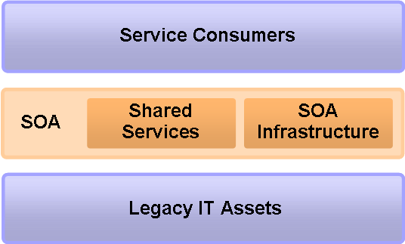
As shown in the diagram above, SOA acts as a value-add layer on top of existing IT assets. It exposes these assets, as well as custom-built capabilities, as shared services. SOA also includes infrastructure to aid in the discovery, management, mediation, monitoring, and security of services. Shared services are made available to various types of Service Consumers in order to rationalize the way business functions are performed and enterprise data is managed.
The following sections provide a deeper dive into these high level topics.

Shared Services

Definition of a Service
A key element is a common vocabulary and thorough understanding of what is meant by a “Service”. This section first defines the terminology that will be used by <Company Long Name> to promote this common understanding of the term “Service”, and then presents various views of the SOA reference architecture.
Services, for the purpose of this reference architecture document, refer to reusable code that is deployed in an IT environment. It does not include activities performed by humans, or products for sale to customers. A logical definition of a service consists of three components: A Contract, its Interface and the Implementation.

Contract
The service contract specifies the purpose, functionality, constraints and usage of a service. A contract is made up of functional and non-functional aspects.
The functional aspect of a contract describes the available operations of a service, and their functional capabilities, in business terms, which will assist in aligning IT with the business to initiate a common language.
Contracts also specify non-functional aspects of service usage, (protocol, security requirements, semantics, transaction requirements, invocation style, quality of service, etc.)
Describe any principles and guidelines adopted by the customer that apply to service contracts

Interface
A Service interface provides a means for the users and consumers of a service to access its functionality according to the contract it offers.
A given physical service implementation may offer multiple standards-based interfaces to allow consumption of the service through different means. For example, an interface may be offered to provide synchronous access to some functionality for interactive usage while an asynchronous interface is provided for other purposes.
Describe any principles and guidelines adopted by the customer that apply to service interfaces, for example: protocol constraints, invocation styles, etc.

Implementation
The implementation is the technical realization of an interface. The implementation part of a service is the actual code, application interface or other technology asset containing functionality that is needed in the enterprise.
The implementation may be accomplished using any technology. Implementations, especially early on, often represent functionality that already exists in an enterprise. Going forward, implementation mechanisms should be aligned to a set of technologies the enterprise intends to support or standardize on.
Describe any principles and guidelines adopted by the customer that apply to service implementations, for example: programming languages, development platforms, frameworks, standards, etc.

Scope of Services
Services are not all created equal. Some are meant to provide standards-based access to low level, very localized entities, while others are meant to represent enterprise-level capabilities in a consistent manner. Still others may be exposed through corporate firewalls to trading partners, customers, or other external audiences. As the scope of influence differs, so to will the principles that govern their creation.
In order to consistently categorize services, <Company Long Name> has defined the following service types:
Put results of workshop here. Example:
Intra-application services – support application layering
Inter-application services – support AI within a portfolio
Inter-portfolio services – support AI across the enterprise
Enterprise level services – support enterprise business applications and processes
Public services – exposed outside the corporate firewall

Scope-Based Constraints
Describe principles and guidelines that apply to the different service types. For example:
For intra-application services, a web service interface is preferred but not required. While web services offer obvious benefits, the limited scope of these services does not necessitate their use. Other non-standard interfaces should be used as needed. No formal qualification process is necessary to justify the use of non-web service interfaces.
All other services will have web services interfaces. Consumers should make every effort to use the web service interface to access the service. Consumers must prove that the web service interface is inadequate in order to justify the need for an alternative.

Separation of Concerns

Objective
In order for services to be versatile and support reuse, there must be a clear separation of concerns in terms of what they do from how they are used. The objective of this section is to describe architectural principles that enforce this separation of concerns to help maximize versatility and reuse.
Example Principles
A service must not have any dependency on the identity of the consumer that invokes it.
Services must not be tied to any particular underlying technology, delivery channel, or physical location. They should be written to accomplish their function regardless of what protocol is used to invoke them, where they physically exist, or on what type of hardware or operating system they run on. This provides for maximum reuse by allowing access through multiple types of interfaces. It also provides greater versatility in how they are deployed and what underlying technologies are used.
Services must be written to leverage common infrastructure and security capabilities wherever possible. Specifically, basic authentication and authorization must be delegated to service infrastructure, separated from the services themselves. Security service infrastructure should be provided by the container, for technologies such as J2EE, but may be provided by security services if needed. In either case, authentication and authorization must not be hard coded into the service logic.

Service Versioning

Objectives
Services, like any other code assets, are bound to change and evolve over time. Changes can be accommodated in a variety of ways, however, following the loose coupling principles of SOA, the impact to consumers should be minimized. For this reason changes should be handled as versions, ideally supporting the ability to have multiple versions running concurrently. There will be times when this is not feasible, such as when an underlying database change is made. But care should be taken to minimize these instances. Failure to do so requires consumers to deploy updates in lock-step with service updates, which can quickly become unwieldy as usage increases.
The following versioning objectives should be met:
List objectives from workshop, for example:
Service providers must be able to release new versions into production without waiting for consumers to certify on them.
Consumers should be able to test and certify on new service versions before switching to the new version in production.
Service providers should base their testing on the contract (black box testing by contract). Consumers may certify for their use based on their own functional test criteria.
Service consumers should not require code modifications in order to access the latest compatible service versions.
Consumers should determine which version they access. (-or-) Service infrastructure should determine which version consumers access. Need to define an approach

Strategy

Describe versioning strategy from workshop, for example:
Approach to version notation: URL based approach vs. content-based routing approach

Principles

List principles from workshop, for example:
Services must support multiple concurrent versions (unless a sufficient business case can be made otherwise)

Guidelines

List guidelines from workshop

Service Messaging
The following section describes service messaging, which pertains to the way messages are passed to services, e.g., the transport protocols and payload formats.

Transports
It is often said that SOA is not just Web Services, and conversely, using Web Services does not constitute SOA. SOA can be implemented using a number of interface protocols and messaging styles. The mechanism most commonly referred to today just happens to be SOAP over HTTP (a form of Web Services) for many reasons, such as:
- Platform independence: HTTP is universally accepted as it underpins the World Wide Web. SOAP is based on XML, which is an extensible text-based language-neutral payload representation.
- Vendor support: Value-add infrastructure, such as service management, monitoring, and mediation products tend to support this medium more-so than any other.
- Standards support: Enterprise quality capabilities, such as security, reliable messaging, and (to some extent) transactions have been addressed by SOAP-based standards.
- Firewall penetration: HTTP passes easily through firewalls and across wide area networks. Other protocols are often blocked by firewalls and therefore don’t permeate complex environments well.
However, SOAP does have some drawbacks, such as:
- Verbosity: XML data representations are much larger than most, which involves more processing overhead and greater network bandwidth.
- Reliability and Security: Not all infrastructure products support the current SOAP standards for reliable messaging, security, and transactions. Care must be taken to avoid SOAP interfaces where these qualities of service can not be provided.
For these reasons, the following principles and guidelines have been defined:

Principles
List principles from workshop, for example:
All services that require a transactional delivery mechanism must use MQ transport.

Guidelines
List guidelines from workshop, for example:
Services should be designed to be idempotent whenever possible.

Payloads
Service payloads may be designed in a number of ways. Assuming a SOAP interface, the payload options may include basic typed parameters, such as strings and integers, or document style input arguments and return values. SOAP may include attachments, which is handy for passing objects such as images or other binary content that doesn’t need to be parsed by the service or intermediaries.

Objectives
List any objectives from workshop

Principles
List principles from workshop, for example:
All services must use document style parameters in the form of one document as an input and one document (or void) as a return.
Input documents must include a customer identifier as an attribute of the primary element.
Anything about service and document namespaces.

Guidelines
List guidelines from workshop

Service Modeling (Optional)
Modeling helps to communicate architectural ideas and, in the case of SOA, can be used as a means for service identification. In addition to traditional software models, such as those to depict the 4+1 Unified Process (UP) Views, modeling may be used in SOA to depict:
- Service interactions
- Service dependencies
- Services packaging & deployment
- Service composition, such as a relationship of services to a business process or portal application
- Service data models

Principles
List principles from workshop, for example which models are required and what modeling formats and tools to use

Guidelines
List guidelines from workshop

SOA Infrastructure
Infrastructure is important to a SOA environment in that it supports the full service development lifecycle. From management of design-time artifacts, to run-time mediation and security, and operational monitoring and management; infrastructure plays a key role.
SOA infrastructure can be broken down into two broad categories: the infrastructure that services are built on, such as hardware, operating systems, development platforms and frameworks; and standalone “end product” infrastructure components that perform specific functions in a SOA environment, such as registries, repositories, and the service bus.

Infrastructure Platform for Services
Infrastructure platforms help to limit the amount of common foundational code that must be hand coded into each service. They may provide significant value through the support of high availability / failover, security enforcement, transactions, and management.
Describe the customer’s requirements for infrastructure platforms, what they’ve standardized on for service development, and what should be handled by the platform vs. embedded into service logic

Infrastructure Components for SOA
Infrastructure components provide significant value in their enablement of loose coupling, service discovery, operational monitoring and management, and policy enforcement. These components are typically specialized products that are purchased to support multiple projects, services, applications, and portfolios. They are generally configuration-driven, with user interfaces designed to make the task of administration easier.
<Company Long Name> has determined the following infrastructure needs shall be met through infrastructure components:
List of needs (not products), may include:
Service mediation: The ability to connect consumers and producers with potentially differing transports, protocols, message formats, and security capabilities
Service discovery: The ability to navigate a taxonomy of services and discover services (or service candidates) that may apply to particular needs.
Service governance: Service lifecycle management, e.g., state of development, and collection of artifacts including contract and associated requirements, interfaces, schemas, policies, and dependencies.
Service Management & Monitoring: The operational monitoring of services, including performance and load metrics, usage, and availability; process exceptions; significant events; key IT performance indicators; and management of same.
Security: Message-level protection, such as malformed or oversized payloads; message-level policy enforcement, such as identity propagation, encryption, and signature requirements; access control policy management; trust mechanisms.
Others
We’ll map strategies and products to needs later.

Service Providers
Service providers come in many forms, including legacy systems, packaged applications, partner applications, messaging systems, custom-built standalone services, business processes, and combinations of these. Initially, most services, or at least the functionality and data to support services, will originate from existing IT assets. Over time, new services will be built to add value to existing functionality, aggregate data, orchestrate activities, and present information in reusable ways.
It is important to note that providing a service is more than simply providing an interface to invoke a business function. The act of service enablement must adhere to the following principles:
Modify per workshop outcome:
An interface must be provided that conforms to this reference architecture
A contract must be provided as specified in this reference architecture
Security policy must be defined and enforced
Versioning strategy must be adhered to
The service must conform to infrastructure rules for discovery, management, monitoring, and governance
Support and enforce usage agreements
The service must be classified using scope and layering categorization
Other concerns?

Service Consumers
Services may be consumed by many types of customers, such as end users, internal applications, partner applications, and event processing systems. They may be exposed through delivery channels such as the intranet, Internet, B2B networks, IVRs, etc.
A number of consumption models may exist within an enterprise, each with their own rules. <Company Long Name> has defined the following consumption models:
List from workshop, may include:
Portfolio use: Usage of services within a portfolio carry no restrictions. It is up to the portfolio owner to manage and regulate usage, capacity, and security of localized services.
Enterprise use: All usage of enterprise-class services or cross-portfolio access must be managed by the xxxx team following yyyy guidelines
Partner use:
Internet use:

Conceptual View
Expanding on the basic high level positioning of SOA, the following conceptual view depicts shared services and service infrastructure in greater detail.
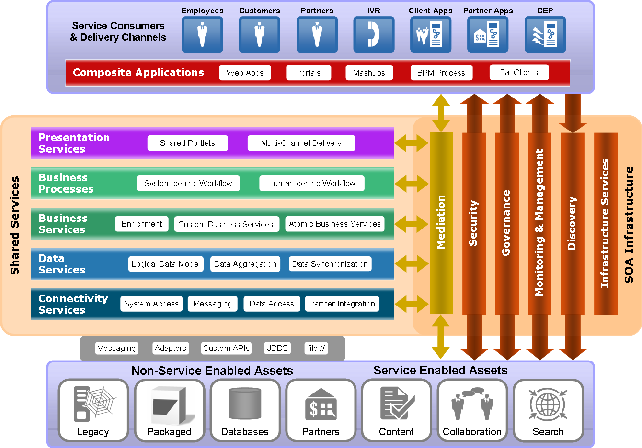
Shared services have been divided into a number of layers, which correspond with common layers of an n-tier architecture. By defining layers it is possible to classify services for the type of function they perform and assign applicable rules for their construction. Each service layer is described in greater detail below. SOA infrastructure is also depicted, based on the needs identified previously in this document.
This diagram is only an example or starting point to your customer’s SOA layering architecture. The number of layers, there names and position as well as the capabilities shown in the SOA infrastructure (middle right) will vary from customer to customer.
The reminder of this section is based on this standard set of layers so do modify number of title of sub-sections based on the actual architecture for the customer.

Connectivity Services

Overview
Connectivity Services provide a means to bridge current application technologies with SOA. They establish connectivity with legacy applications that do not inherently provide service oriented interfaces. Connectivity may be accomplished using a variety of means, such as messaging systems, application adapters, and custom code. Connectivity services expose the functions of legacy systems as services in an SOA environment. They provide standards based interfaces, such as SOAP, which are then consumed by higher level services or customer applications through service infrastructure.
Services exposed at this layer are not intended to reflect business context in any way. Being context-neutral they can be used in many different business scenarios. Data obtained by these services will usually map directly to data representations in the native legacy systems. Adding business context or data mapping will effectively promote them to a higher level (business or data services).

Principles
List principles from workshop, for example:
Connectivity Services must be stateless.
Connectivity Services may translate the representation of data, e.g., to and from XML, but do not apply rules-based transformation or aggregate data from multiple sources.
Connectivity Services must not include business logic.

Guidelines
List guidelines from workshop

Data Services

Overview
Data Services are used to access data from various sources using many different technologies, and present data in a business-friendly form. Data may originate in various databases, flat files, XML files, and legacy systems. Data Services offer a way to aggregate, transform, and synchronize data from multiple sources. They expose data in a format that best supports business services and composite business applications. This creates an abstraction between the users of data and the sources of data. Users of data do not need to be concerned with where data is stored, how it is stored, or how it is represented in its native form. They can work with representations (schemas) of greater business value, which are defined by data architects.
Data Services may access data directly, or may use Connectivity Services to obtain data from legacy applications. Connectivity Services provide a means to interact with legacy systems through APIs rather than directly to the database. Though this may add processing overhead, it is often preferred when updates to data might affect applications that rely on the data.
Like Connectivity Services, Data Services do not include any business rules. This allows them to be reused in different business contexts without modification. They represent business objects, such as customer, employee, and order, with the associated logic for managing such constructs.

Principles
List principles from workshop, for example:
Data services must be tied to an enterprise information model
Data services must not contain business logic
Data services must be stateless

Guidelines
List guidelines from workshop

Business Services

Overview
Business Services are the most commonly talked about services in a SOA. In this architecture we divide Business Services into two categories – services that have been defined as reusable processes by a business analyst (Business Process Services), and services that have been defined by IT to satisfy specific business needs. This section describes the latter.
Business Services may be identified in many ways, including the top-down approach to business process decomposition. In this approach, business processes, such as taking and fulfilling orders, establishing new customers, and purchasing products, are decomposed into individual activities. Activities may either be automated or performed manually. Automated activities may be implemented as business services. Business services can then be reused among multiple processes or made available for use outside of business processes.
Another common way to identify Business Services is through functional decomposition. This involves the decomposition of a project or application into various logical functions. Some functions may be deemed reusable by other projects and application while others will tend to be very specific to a single application. The more reusable functions can be further evaluated and potentially developed as Business Services.
The reuse potential of Business Services is generally less than Data and Connectivity Services. As the level of complexity increases, the likelihood of reuse is reduced. For this reason Business Services offer more value as a way to rationalize IT operations than as a way to promote reuse. By abstracting the users of services from the system interactions needed to perform those services, they provide a way for IT to evolve its systems without a direct impact to the users.

Principles
List principles from workshop, for example:
Business services must be stateless.
All transactional processing required by a Business Service must be self-contained within the service. Transactions cannot span service boundaries.

Guidelines
List guidelines from workshop, for example:
Business services should be designed to be idempotent.
Business services should have an “undo” method to correspond with each “execute” method.

Business Process Services

Overview
Business Process Services expose shared business processes as services. They can be complete business processes or independently defined subprocesses. For example, the process for fulfilling a product order may differ slightly depending on the manner in which it was ordered. The common portion of all order processes may be defined once and reused by other higher level processes that are unique to the method of ordering. This level of reuse is most valuable for establishing consistency for doing business. Exposed as services, these subprocesses can be easily incorporated into higher level processes while being managed by service infrastructure.
Business Process Services may be stateless or stateful. Stateless services will consist entirely of automated activities that are executed within the context of a single transaction. Stateful process services may be long running, involve human interaction, and encompass multiple atomic transactions. As such, the initial response to a stateful service invocation will not reflect the completion of that service, but rather an acknowledgement of invocation. A separate callback notification would be required to inform the consumer of service completion or provide intermediate status updates.

Principles
List principles from workshop, for example:
All Business Services that require the preservation of intermediate state between the invocation of the service and its completion and final reply to the consumer will be represented as Business Process Services.
The state of any Business Process Services instance will be monitorable at any given point in time.

Guidelines
List guidelines from workshop, such as standards to follow (BPEL, BPMN), etc.

Presentation Services

Overview
All lower level service layers may be exposed to users through a user interface such as a portal application. The portal application is divided into portlets, which contain information from various sources and the ability to interact with underlying systems. Using portal federation technologies such as WSRP, portal applications can be developed and deployed in a componentized manner. That is, the portal framework (layout, look and feel, security) can be developed separately from the portlets it displays. Furthermore, portlets may be developed and deployed separately from each other. This permits a separation of concerns with regards to system development and ownership. The groups responsible for services and applications that the portlets expose can develop and maintain the portlets themselves. Portal applications can then consume these portlets as desired.
In this architecture we define Presentation Services as portlets that are made available via WSRP. They can be deployed as part of the shared services infrastructure and leveraged by many different portal applications. Their greatest value is the ability to reuse entire functional capabilities including presentation logic. Reuse at this level avoids the need for recoding business logic and user interface logic. Like Business Services, Presentation Services may represent simple operations (stock quote, calculator), or complex processes (order management, customer service).

Principles
List principles from workshop

Guidelines
List guidelines from workshop

Composite Applications

Overview
Composite Applications is a term used to define applications built primarily of shared services. Common examples include portals and BPM processes. They may identify business, data, and connectivity needs that can be developed in the form of services. This is often referred to as top-down service identification. In essence, the Composite Application is defined first, and the services used to compose the application are then identified and constructed. Composite Applications may evolve and expand over time as additional services are created. This promotes incremental business value through the iterative development of new services, reducing the risk associated with applications by delivering functionality in smaller, more consistent increments.
Notice that business processes can fall into either the Business Process Services or Composite Applications layers. Their placement depends on whether or not the process is implemented as a shared service. Business Process Services are exposed as services and must conform to associated governing principles. Processes not considered reusable or shared services themselves are identified as Composite Applications (if they leverage services to perform some of their processing).
As the portfolio of services increases, the ability to rapidly compose new applications increases. The ratio of services that already exist vs. services that need to be built changes over time. Eventually, composite applications may be composed almost entirely of existing services. At this point it is conceivable that applications can be built with very minimal development effort.

Service Mediation

Overview
The service bus provides essential services for transportation, protocol conversion, data transformation, and routing of messages between services in various layers. The service bus provides both synchronous and asynchronous modes of message transportation.
Translation and transformation services provided by the service bus are invoked implicitly (by the bus, via configuration) or explicitly (by services) to convert messages to and from different formats (XML to EDI), or different structures (XML to XML). Translation may be used to bridge incompatible service consumers and producers, and it may be used to transform messages to conform to schema changes. Translation is configured on a per-service basis, and may be changed via configuration.
Routing services are most commonly used to route messages between services and layers. Routing logic is typically configured based on message type, key contents, subscriber and publisher information, and filtering logic. Routing may be used to route customers to services based on a variety of factors, such as SLA requirements, QoS requirements, and versioning. The service bus may also be used to deny access by customer applications that have not been “registered”, (formally entered into the routing tables).
The service bus may be used to perform certain security duties such as authentication of end users, authorization of users to services, credential mapping to support legacy system integration, and auditing of service requests. Incorporating this logic into the service bus provide a single centralized way to introduce and manage security policy.
Given the positioning of a service bus as an intermediary between service producers and service consumers, the service bus is in a unique position to provide operational visibility into the status of a SOA. The service bus can provide metrics, such as response time, up time, and throughput for all services it supports. These metrics can be displayed in an O&M dashboard to provide early warning of trends and potential problems. In addition, service metrics can be collected and compared to service contracts in order to measure actual service availability, scalability, and performance results vs. expected characteristics.

Principles
List principles from workshop, for example:
All service requests must go through the service bus.

Guidelines
List guidelines from workshop

Service Discovery:

Overview
Describe approach to service discovery. This is generally accomplished either via a registry or repository. The registry supports dynamic binding, but this paradigm breaks strict controls over who has access to what as well as the management of capacity and service level agreements. The registry also provides a way to locate and share common policies such as instances of WS-Security Policy.
Either the registry or repository can be used for design time (static) discovery and binding. There is much overlap between these products, however the repository seems to have the greatest value when governance is factored in.

Principles
List principles from workshop

Guidelines
List guidelines from workshop

Service Governance

Overview
Service governance can be classified into the following concerns:
- Service lifecycle management
- Service asset management
- Dependency tracking
- Formal usage agreement management
- Others?
Describe what the customer wants the repository (or other product) to do, how it will be used, and who is responsible for using it.

Principles
List principles from workshop

Guidelines
List guidelines from workshop

Service Management and Monitoring

Overview
Describe customer’s preferred approach to monitoring, the type of data to collect, how it will be collected, and how it will be displayed.
Describe how services will be managed, for instance, how they will be configured in the infrastructure upon deployment, how ongoing capacity management will be done, how they will be deprecated and retired.

Principles
List principles from workshop

Guidelines
List guidelines from workshop

SOA Security

Overview
SOA is a different approach to application architecture, and as such introduces some new twists to traditional application security. The most common difference is the need for message level security. This is due to the distributed nature of services in a SOA environment, the concept of service chaining (services invoking other services), and the introduction of mediation or proxy points between providers and consumers.
Message level security protects messages from end to end, from the origination point of a service request, through intermediaries, through service providers, and services they might call. It protects messages while in transit and at rest (in queues and databases). This make it an ideal solution for message protection, going a step beyond transport level, or point to point security.
There are a number of standards available that pertain to message level security for Web Services. <Company Long Name> has chosen to standardize on …
Explain the customer’s approach to message level security
Other security concerns may include:
Message level security policies (WS-SecurityPolicy), policy enforcement, and policy management.
Data level security – entitlements on data elements and data redaction. This allows a service to be used by multiple audiences and return the appropriate data
Entitlements management – the ability to define roles and policies across disparate security domains to create a unified approach to access control.
Trust mechanisms – the ability to bridge security domains by establishing trust, mapping identity tokens (credential mapping), establishing assertion authorities, etc.
Explain the customer’s approach to any of these or other areas of security that were defined as part of RAPS

Principles
List principles from workshop, for example:
All service invocations will be audited via the service bus.

Guidelines
List guidelines from workshop, for example:
The preferred mechanism for identity propagation is SAML assertions.

Infrastructure Services

Overview
Infrastructure Services is the mechanism for exposing SOA infrastructure components as a service. Examples include security services, monitoring and management services, and registry services, as well as common utility services, such as logging and notification. These services can be used by any of the other service layers. They may be accessed via the service bus, as a fully registered and managed service, or through a proprietary framework, such as a security framework.
List any infrastructure services the customer has an interest in. These are considered candidates for the roadmap phase of RAPS

Principles
List principles from workshop

Guidelines
List guidelines from workshop

Implementation View
With the SOA concepts well defined, the next step for the reference architecture is to provide guidance on the technologies used to implement it. Starting with a logical view of the architecture, shown below, the Implementation View will depict how each layer and functional component will be realized through technology and products.
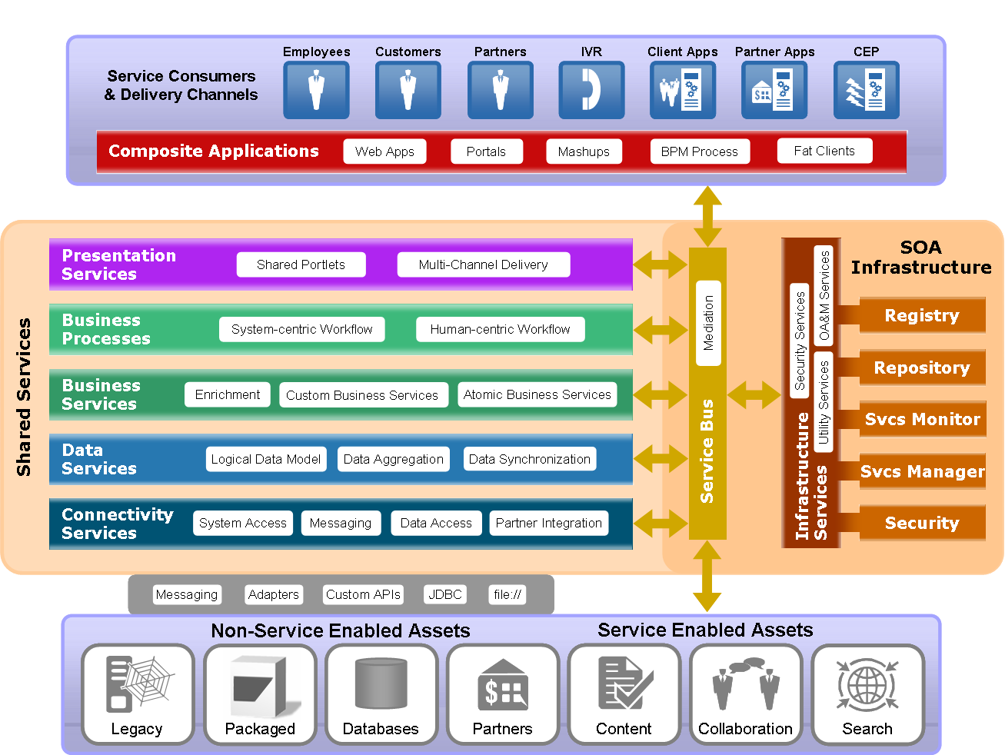
This diagram is only an example or starting point to your customer’s implementation view. The number of layers, there names and position as well as the products shown in the SOA infrastructure (middle right) will vary from customer to customer.

Technology and Product Mapping
Enter results from workshop here. Results may include actual product names, or placeholders for product names. For instance the customer might decide to use a particular product for ESB, and know they need to select a registry but don’t yet know which one. Results may also include technology constraints. For example, they may define WSRP for presentation services and standardize on J2EE for creating business services.
There are a number of ways to organize this information, such as:
Tabular form: construct a spreadsheet to map layers & components with products & technologies
Use the same logical diagram and replace the text in white boxes with technologies & products
Enter the information in plain text form
In most cases customers will not settle on a single product and/or technology, but will instead leave this open-ended. The infrastructure components are more likely to be resolved to a limited solution set than the service layers, so it might make more sense to group all service layers together (if the customer is willing to provide any constraints at all on service implementation).

Deployment View
The Deployment View provides a perspective of what the architecture will look like once it is deployed.

Service Packaging
The customer must provide guidance on how services will be packaged with respect to applications for which they were initially created. The preferred method is to package services separately from applications so they do not share the same maintenance and versioning cycles. This allows for greater control and predictability of service performance and load capabilities, and reduces down time as a result of application maintenance windows and bug fixes.
The customer must also determine their approach to service packaging that provides the right mix of service autonomy vs. ease of management. On one hand, each service could be packaged and deployed separately (separate ear files). This allows each to be maintained individually, but may make management more difficult as the number of services increases. Another approach is to group services together into a common packaging unit based on service type, service level agreements, and/or inter-dependencies and common resource dependencies. The trade-off is that when a service is taken offline for maintenance, all other services in the same packaging unit will be affected.
Enter results of workshop here.

Service Deployment Strategy
Service deployment strategy defines the way services will be deployed onto production hardware. This includes strategies for high availability, resource allocation, and site redundancy (if applicable).
Describe the customer’s strategy for service deployment. Include approach to clustering, HA, and ownership of resources (what types of hardware will be used and who owns it). They may have a very centralized approach to service engineering, such as a software factory for services, or a federated approach where each portfolio manages its own services.

Infrastructure Deployment Strategy
Describe how SOA infrastructure will be deployed. Like service deployment this could be centralized or federated, or a mix of the two. For instance the customer might federate the service bus and services but centralize the repository.

SOA and Enterprise Architecture
The adoption of SOA can have an effect on other areas of enterprise architecture. The intent of this section is to provide an overview of these effects and guidance on such matters. Further information about any of these aspects of enterprise architecture can be found in separate documents.
Include the sections that are relevant to the customer’s situation and/or are requested by the customer. Add references to other customer-owned documents as applicable. Some topics (such as security and ESC) may need much more time than RAPS allows, resulting in a very high level view at this time and possible follow-on planning engagements.

Application Architecture
Describe how SOA affects application architecture. This may include:
The types of applications (custom, packaged, legacy, etc.) expected to play a significant role in the SOA strategy.
The general way in which services will be defined (top-down, bottom-up, etc).
How applications and services are built (in house, outsourced, etc.)
How SOA will change the way they approach application construction, purchasing, upgrades, or leasing.

Data Architecture
Describe how SOA affects data architecture. This may include:
Background on data authority (who owns and maintains data).
Data architecture initiatives (MDM, EDR, data warehousing, etc).
The intended role of data services.
How schemas will be defined with respect to canonical models and other data initiatives.

Integration Architecture
Describe how SOA affects integration architecture. This may include:
Current integration architecture mechanisms (message bus, adapters, etc.)
How SOA changes this, and how SOA will bridge existing mechanisms.
The use of connectivity services.

Security Architecture
Describe how SOA affects security architecture. This may include:
Use of XML firewalls and gateways
Use of message level security.
Security domains and trust zones – how SOA bridges these.
Effects on identity, role, policy enforcement and management
Role of security services, or Security as a Service

OA&M
Describe how SOA affects OA&M. This may include:
How services will be operationally monitored
What needs to be monitored
The role of infrastructure for OA&M.
How services and SOA infrastructure will plug into existing OA&M infrastructure

SOA and Business Process Management
Describe how SOA affects BPM. This may include:
Current BPM initiatives
Role of SOA – how services will be incorporated.

SOA and Event-Driven Architecture
Describe how SOA affects EDA. This may include:
Current EDA initiatives
Role of SOA – how services will be incorporated.

SOA and Enterprise Social Computing
Describe how SOA affects ESC. This may include:
Current ESC initiatives
Role of SOA – how services will be incorporated.

Appendix A - Glossary

Appendix B – Referenced Documents

Doc. No. | Document Name | Version | Date | Author
1
2
3
4

Open and Closed Issues
Add open issues that you identify while writing or reviewing this document to the open issues section. As you resolve issues, move them to the closed issues section and keep the issue ID the same. Include an explanation of the resolution.
When this work product is complete, any open issues should be transferred to the project- or process-level Issue Log (PJM and managed using a project level Issue Form (PJM). In addition, the open items should remain in the open issues section of this work product, but flagged in the resolution column as being transferred.

Open Issues

ID | Issue | Resolution | Responsibility | Target Date | Impact Date

Closed Issues

ID | Issue | Resolution | Responsibility | Target Date | Impact Date

